4.1 Homepage
4.1.1 overview
You can enter this page by clicking "Homepage" on the navigation bar. The primary function of the Homepage is to display today's recipes and meals logged and confirmed via the "Identifier," allowing users to understand their intake status for the day. This page includes sections for Check-in, Date Bar, Status Bar, "Today’s Meals," and "Extra Meals". 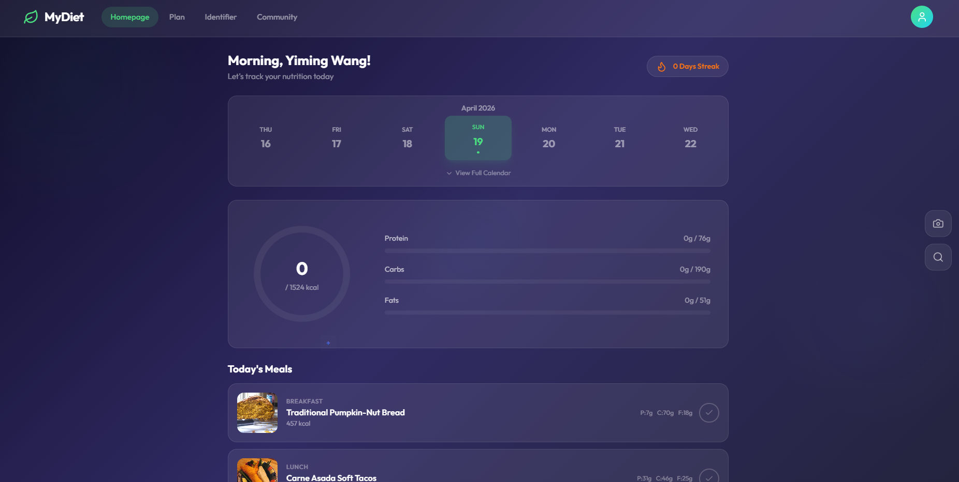
4.1.2 Check-in
Clicking the fire icon in the top right corner increases the check-in streak by one day. 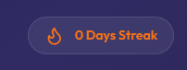 
4.1.3 日期栏
This section displays the dates; users can click "view full calendar" to see the complete calendar. 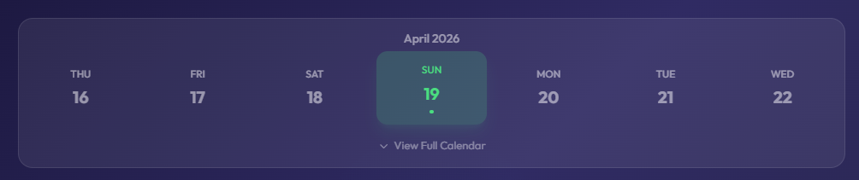
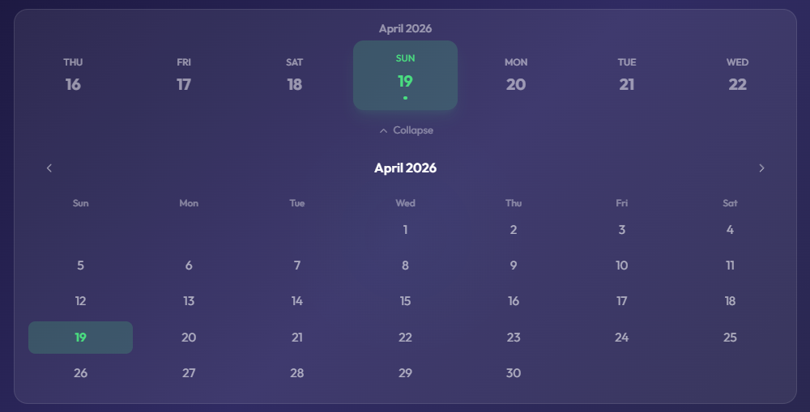
Clicking on past or future dates allows users to view the meals for those specific days, but they cannot be modified. The system will prompt: "Viewing data for [Date] — meal check-in is only available today". 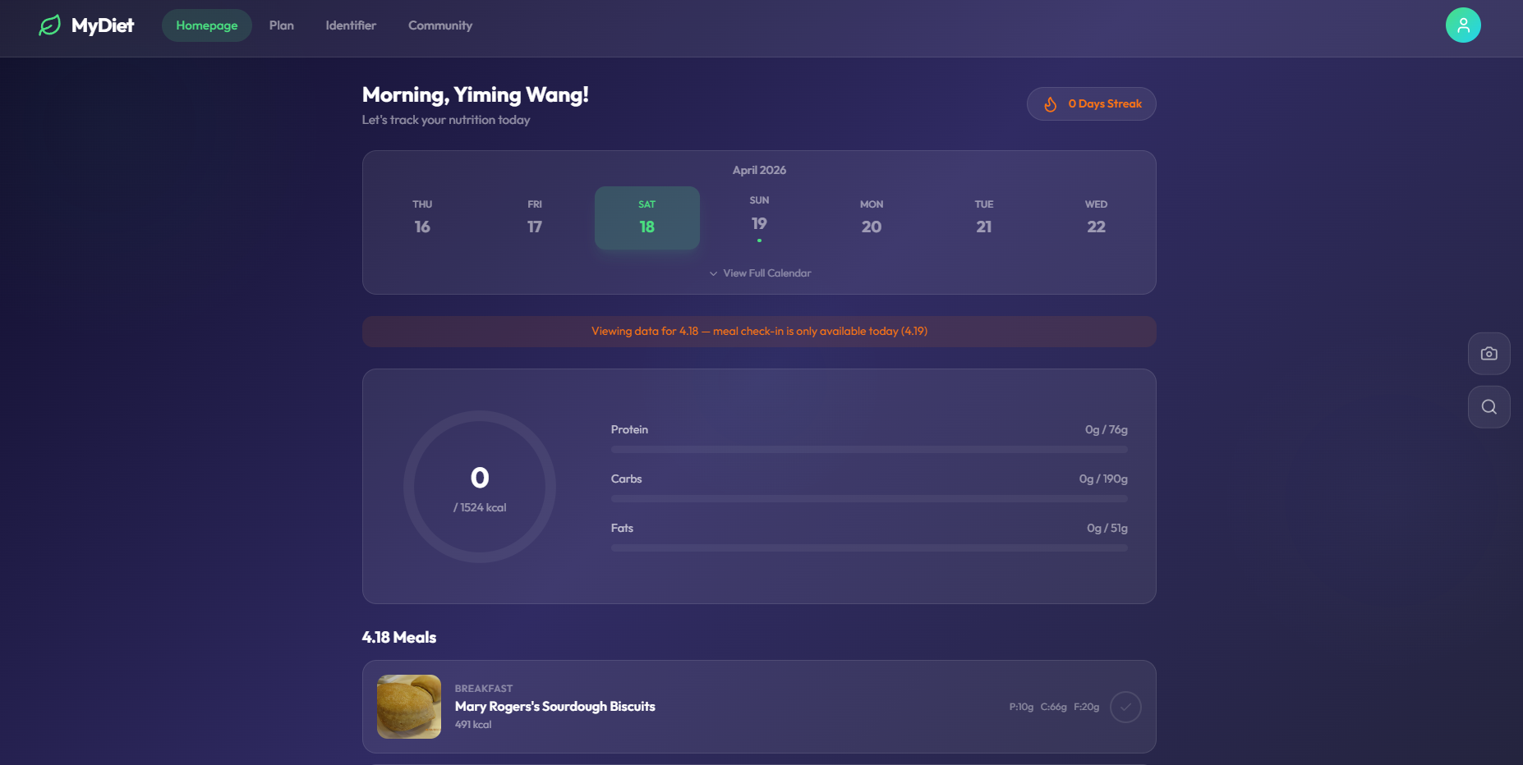
4.1.4 Status Bar
This area displays the total calories, Protein, Carbs, and Fats consumed today. As shown in the image, each metric has a designated upper limit. 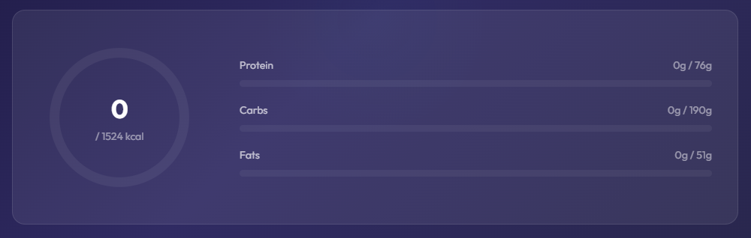
4.1.5 Today’s Meals
This section displays the recommended meals for the day. Clicking the checkmark button (√) will correspondingly increase the values in the status bar and is accompanied by a confetti effect for celebration, providing emotional value to the user. 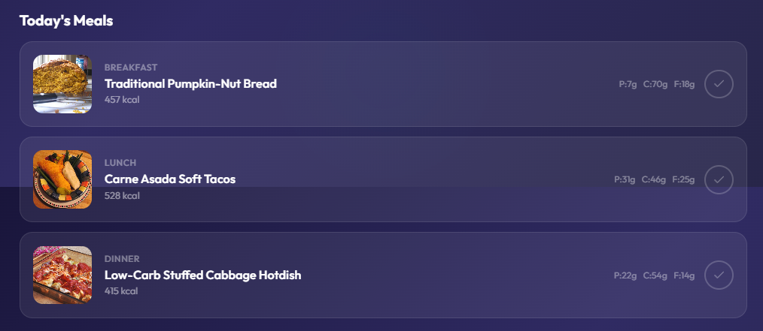
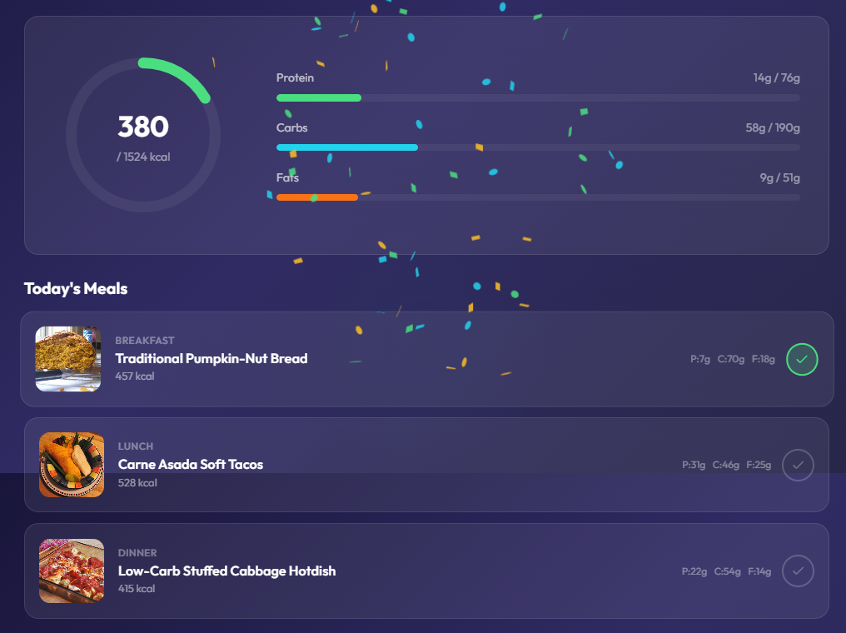
4.1.6 Extra Meals
Food items added using the Identifier will be reflected here. 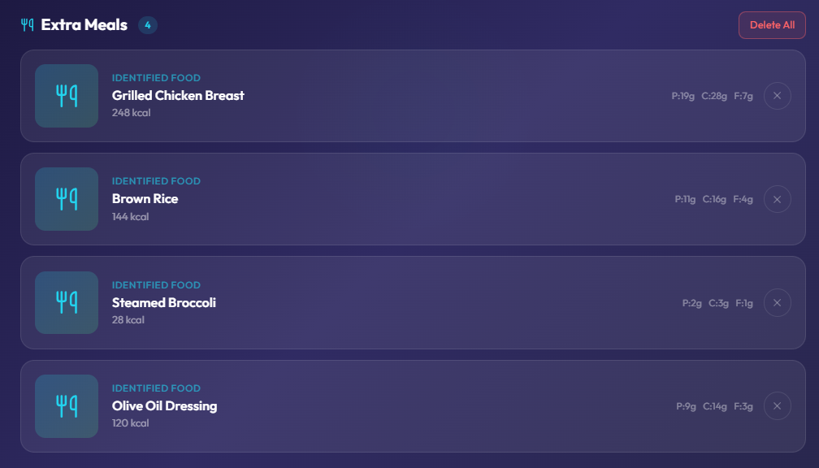
Clicking the "×" icon allows you to delete the corresponding food entry.
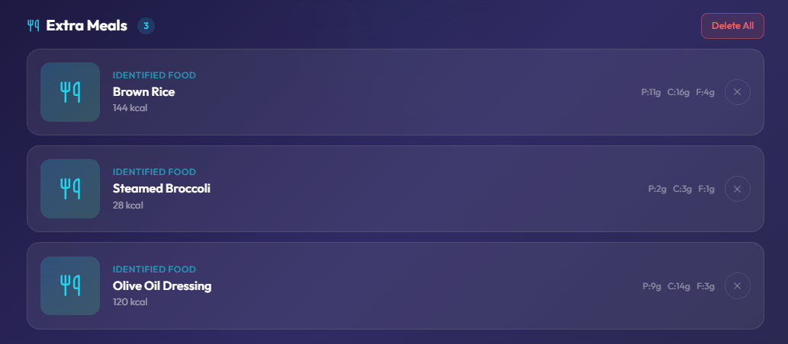
Clicking "delete all" will clear all extra meal records. 
4.1.7 Other Components
Clicking the camera button will jump directly to the Identifier interface. Clicking the search button will jump directly to the Community interface.


4.2 Profile
4.2.1 Overview
Click the circular avatar on the rightmost of the navigation bar to enter this page. This page serves as a summary of the other four interfaces, containing the Personal Profile, Change Account & Sign out, Health Metrics, Body Composition History, Preferences & Restrictions, Social Summary, Privacy & Settings, Following, and My published Posts.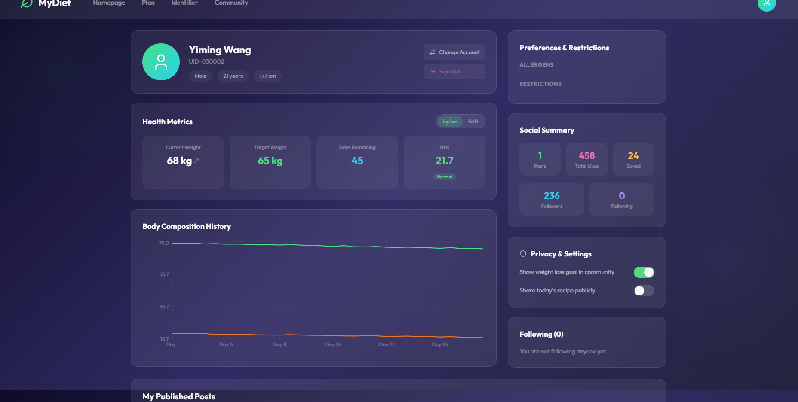
4.2.2 Personal Profile
Includes basic information such as Name, UID, Gender, Age, and Height.
4.2.3 Change Account & Sign out
Provides buttons to Change Account or Sign out of the current session securely.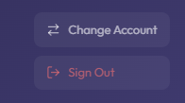
4.2.4 Health Metrics
Includes your Current Weight, Target Weight, Days remaining, and BMI。
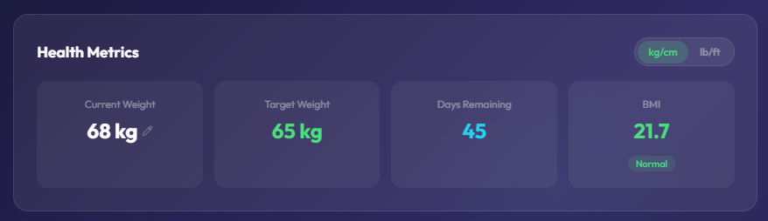
A toggle is provided to switch between kg/cm and lb/ft units.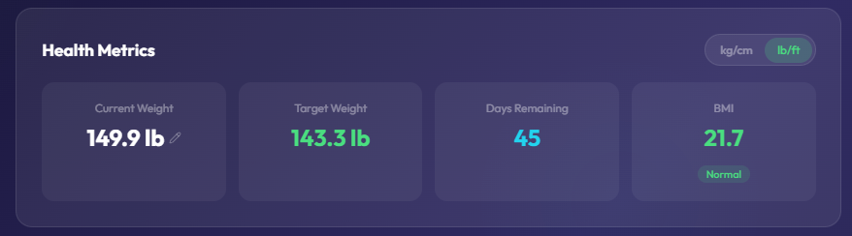
4.2.5 Body Composition History
Displays a visual chart of weight and body fat changes over time. Hover the cursor over any data point on the chart to view specific details for that date 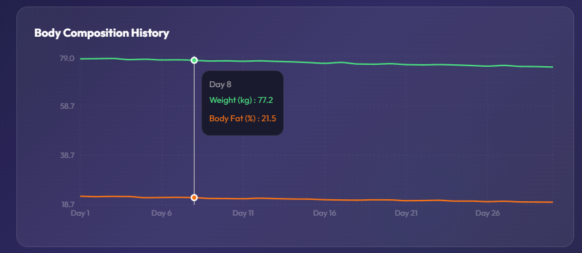
4.2.6 preferences & restrictions
Displays the Allergens and Restrictions you have saved in your profile.
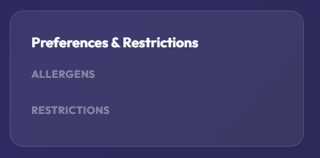
4.2.7 Social Summary
Shows a summary of your community activity, including the number of Posts, Total Likes, Saved, Followers, and Following.
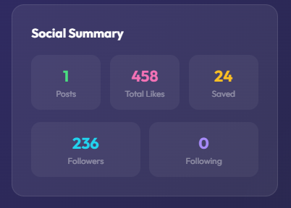
4.2.8 Privacy & Settings
Allows users to toggle the visibility of their health goals and shared recipes within the community.
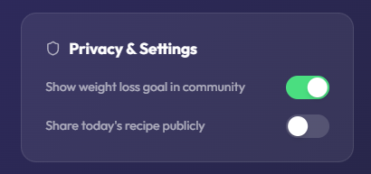
4.2.9 Following List
Displays a list of all users you are currently following.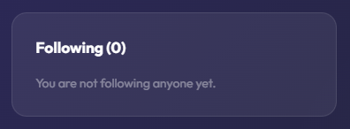
4.2.10 My Posts
A gallery showcasing all the posts you have published to the community.

